Simran Shilky

9918103027

F1

**Assignment 8 Solutions**

Q1)import numpy as np

from scipy.sparse import csr_matrix

list1=[

[1,0,0],

[0,1,0],

[0,0,1]

]

res= np.array(list1)

print(csr_matrix(res))

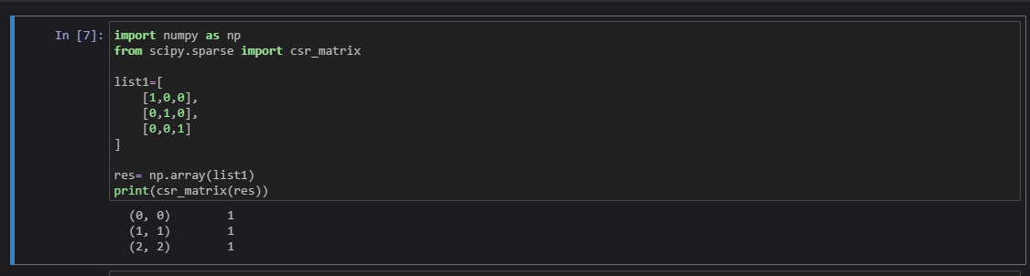

Q2)import pandas as pd

data = pd.read_csv('C:\\Users\\Rajesh kumar\\Downloads\\iris_csv.csv')

print (data.describe())

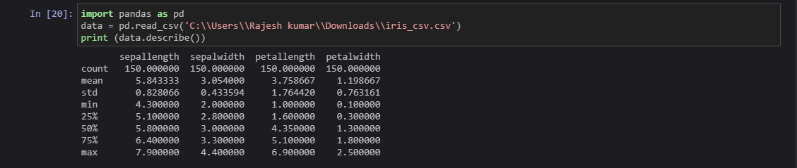

Q3)import pandas as pd

from sklearn.model_selection import train_test_split

iris = pd.read_csv("C:\\Users\\Rajesh kumar\\Downloads\\iris_csv.csv")

X = iris.iloc[:, :-1].values

y = iris.iloc[:, 4].values

X_train, X_test, y_train, y_test = train_test_split(X, y, test_size=0.30)

print("\n70% train data:")

print(X_train)

print(y_train)

print("\n30% test data:")

print(X_test)

print(y_test)

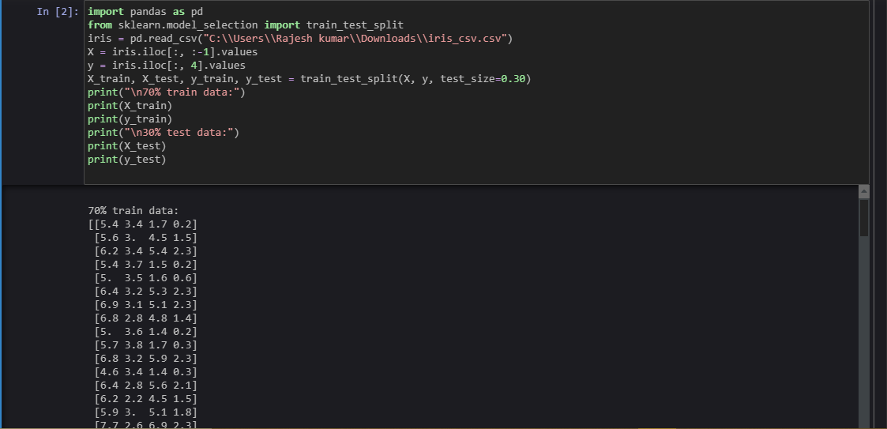

Q4)import pandas as pd

from sklearn.model_selection import train_test_split

from sklearn.neighbors import KNeighborsClassifier

iris = pd.read_csv("C:\\Users\\Rajesh kumar\\Downloads\\iris_csv.csv")

X = iris.iloc[:, :-1].values

y = iris.iloc[:, 4].values

X_train, X_test, y_train, y_test = train_test_split(X, y, test_size=0.20)

#Create KNN Classifier

#Number of neighbors to use by default for kneighbors queries.

knn = KNeighborsClassifier(n_neighbors=5)

#Train the model using the training sets

knn.fit(X_train, y_train)

#Predict the response for test dataset

print("Response for test dataset:")

y_pred = knn.predict(X_test)

print(y_pred)

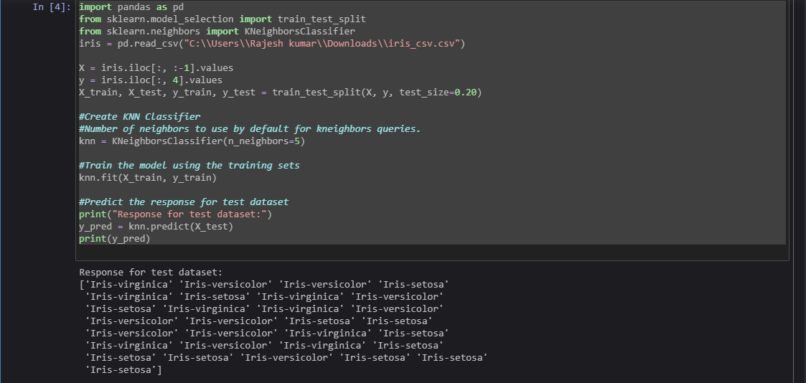

Q5)# Importing Libraries

import numpy as np

import pandas as pd

import matplotlib.pyplot as plt

# Importing Data

from sklearn.datasets import load_boston

boston = load_boston()

# Input Data

x = boston.data

# Output Data

y = boston.target

# splitting data to training and testing dataset.

from sklearn.model_selection import train_test_split

xtrain, xtest, ytrain, ytest = train_test_split(x, y, test_size =0.2,

random_state = 0)

print("xtrain shape : ", xtrain.shape)

print("xtest shape : ", xtest.shape)

print("ytrain shape : ", ytrain.shape)

print("ytest shape : ", ytest.shape)

# Fitting Multi Linear regression model to training model

from sklearn.linear_model import LinearRegression

regressor = LinearRegression()

regressor.fit(xtrain, ytrain)

# predicting the test set results

y_pred = regressor.predict(xtest)

plt.scatter(ytest, y_pred, c = 'green')

plt.xlabel("Price: in $1000's")

plt.ylabel("Predicted value")

plt.title("True value vs predicted value : Linear Regression")

plt.show()

